# SUMMARY:

* Having **around 14+** years of experience and **8 plus years** of relevant SAP SLT, SAP BW/HANA, ABAP with SAC experience in the leading IT Organizations.
* SAP HANA 2.0, SAP BW/4HANA and SAP data modeler, also worked on SAP S/4HANA Custom CDS views.
* Expertise in development, testing and Production Support and troubleshooting in the production environment.
* Ability to adapt to fast changing technical environments and up gradation and integrations to latest developments.
* Quick learner, willing to accept new challenges which allow me to expand my skill set.

# SAP BW/HANA:

* Replicated data using SLT as per requirements.
* CFIN Configuration and data replication in SLT Finance.
* SAP to NON-SAP and Non SAP to SAP configuration in SLT.
* Issues resolutions in SLT.
* Created Transient providers, Composite providers, Open ODS views, Advanced DSO's SAP BW HANA.
* Imported BW Info providers into SAP HANA by configuring BW with HANA Studio.
* Expertise in Data Modeling Techniques like Info Cubes, Data staging objects, Transformations, DTPs, Data Marts, Info Packages, Multi providers and Installation of Business content objects.
* Transport the Objects from Development to Quality System and Load the Data into Data Targets.
* Expertise in designing BEX with Structures, Free Characteristics, Filters, Formulas, Calculated Key Figures and Restricted Key Figures, Conditions, Variables, Exceptions, and Workbooks.
* Data Extraction activity and use ABAP in writing Enhancement, routines, Change request, APDs.
* Perform analysis and design, wrote technical specifications, configuration and programming in the SAP BW environment and including testing and implementation.
* After User Acceptance Testing Transport, the Objects to production System and Tested the Objects/Reports in Production system before handing over to the Users.
* Involved in high priority ticket resolution (production issues) and fixing the same.
* Created Customer exist Variable as per Business Logic.
* End to end BW development, from data extraction in ECC, to data modeling & query design
* BW configuration, ETL background and Info Cubes design, Performance and tuning, strong on End to End BW Configurations and Customizations from Extraction, Staging, Loading, Transport, and Reporting through BEx Analyzer, and Performance.
* Experience in working with HANA Optimized objects, Composite provider and Hybrid Providers.
* Worked on Advanced DSO.
* Worked directly with key members of our business units to define requirements and overall system design.
* Worked Directly with the SAP HANA DB team to work through critical bugs.
* Creating and Modifying the Flat and Hierarchical dimensions. Maintaining Dimension Members and its Properties

**Certifications**

* SAP BW 7.0
* SAP BW 7.4 on HANA.
* SAP SLT
* SAP BW/4HANA 2.0

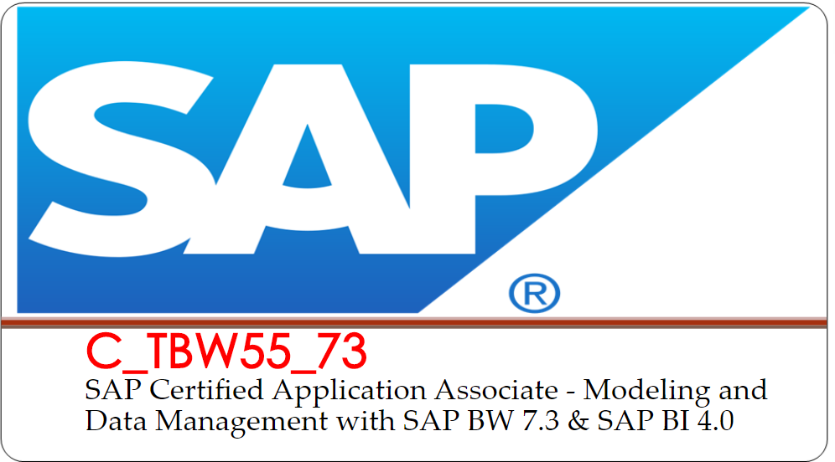

# P ROFESSIONAL SUMMARY:

* + Working as Lead Technical Consultant with Tieto India Pvt Ltdfrom April 2021 to till date.
  + Worked as Senior Consultant with **HCL Technologies Ltd** from July 2015 to April 2021.
  + worked as Technical Lead in IGATE Global pvt ltd from July 2013 to June 2015.
  + Worked as international marketing executive in Heuristic Computing & Logical Systems Pvt Ltd, Hyderabad from July 2011 to June 2013.
  + Worked as Data Analyst from Jan 2007 to Dec 2008 in APSAIDC Ltd.

**PROFESSIONAL PROJECT EXPERIENCE**

**Project #5**

# Client : UPM

**Project Type : Development and Support.**

**Company : Tieto India**

**Role : Lead Technical Consultant**

# UPM-Kymmene Oyj is a Finnish forest industry company. UPM-Kymmene was formed by the merger of Kymmene Corporation with Repola Oy and its subsidiary United Paper Mills Ltd in 1996.[2] UPM consists of six business areas: UPM Biorefining, UPM Energy, UPM Raflatac, UPM Specialty Papers, UPM Communication Papers and UPM Plywood.

# Project Responsibilities

**S AP BW/HANA Specialist (including BW/4HANA) and SAC**

Responsibilities:

* + BW4 Migration and Development.
    - LSA++
    - Composite Providers
    - ADSOs.
    - OpenODS view to access S/4 CDS Views.
    - BW Queries and enhancements.
    - BW4 Cockpit
    - BW4 Performance Optimization.
    - BW4 Production Support.
* Responsible for efficiently delivering the project and suprtvising the implementation team.
* Exposing SC Data Models into SAC using live connection
* Successfully created Dashboard story in SAC using canvas, responsive pages and digital boardroom.
* Successfully display story in mobile SAC app using responsive pages.
* Tested and resolved data issues in SAC.
* **Worked on CFIN configuration, data replication and issues resolution development and support.**
* **Worked on SAP to Non-SAP source and target configurations and data replications.**
* **Worked on various source and target connections as a developer.**
* **Supported on SLT during S4Upgrade.**



**Project #4**

# Client : Britvic

**Project Type : Development and Support.**

**Company : HCL Technologies pvt ltd**

**Role : Senior Consultant**

Barr **Britvic Soft Drinks** plc was a proposed company to be founded by the merger between two British **soft** drink manufacturers, A G Barr and **Britvic**. The company would have produced such well known brands as Robinsons, Irn-Bru and Tango.

# Project Responsibilities

**S AP BW/HANA Specialist (including BW/4HANA)**

Responsibilities:

* BW4 implementation Blueprinting
* Implemented FI, SD end-to-end from S/4 to BW to BW4 Cockpit.
  + BW4 Development from scratch including LSA++, Composite Providers ADSOs, including planning ADSOs, OpenODS view to access S/4 CDS Views.
  + BW Queries and enhancements.
  + BW4 Cockpit
* BW4 Performance Optimization, BW4 Production Support

# P roject #3 Client : Thomas Cook

**Project Type : Implementation.**

**Company : HCL Technologies pvt ltd**

**Role : Senior Consultant Project Responsibilities**

**S AP BW/HANA 2.0 | SAC Greenfield Implementation**

The project was BW/4HANA implementation

* + Implemented FI, SD and EWM dataflow end-to-end from S/4 to BW to BW4 Cockpit.
  + BW4 Development from scratch including LSA++, Composite Providers ADSOs, including planning ADSOs, OpenODS view to access S/4 CDS Views.
  + BW Queries and enhancements.
  + BW4 Cockpit
  + BW4 ABAP Coding including BADI and AMDP.



* + BW4 Performance Optimization, BW4 Production Support
  + Connecting BW4 Queries to Lumira Designer and Discovery.

# P roject #2

**Client : Bank of Ireland (IRELAND)**

**Environment : SAP BI 7.4/7.3 support and development Project Type : Implementation and Support.**

**Company : HCL Technologies pvt ltd**

**Role : Senior Consultant Brief description of the project:**

The Bank of Ireland is a commercial bank operation in Ireland and one of the traditional 'Big Four' Irish banks. Historically the premier banking organization in Ireland, the Bank occupies a unique position in Irish banking history. At the core of the modern-day group is the old Bank of Ireland, the ancient institution established by Royal Charter in 1783

# Project Responsibilities

* Scheduled data loads to BW from SAP R/3, Monitored data loads which are running an hourly, daily, weekly and monthly.
* Monitored data loads through Process chains, if any error occurs while loading data into BW from source systems.
* Monitored of Info packages and analyzing the reasons for frequent failures of Info package.
* Extensively worked in Business information Warehouse Info cubes. ODS, Info objects, Transfer rules, Update rules, Info package, Info object catalogs, Data Sources, Data extraction, Business content, Data marts, Process chains.
* Involved in Performance issues by creating aggregates, Partioning, Indexes and Compression.
* Handled Transport co-originator activities.
* Maintained Coordinator activities for Onsite and Offshore.
* Updated weekly status in leads meeting and onsite call.
* Involved Process chains for Master data and Transaction Data.
* Handled the 2nd level tickets with maintaining the SLA.
* Handled of Change Requests as per the User requirements. Validate the change request submitted by the client.
* Prepare the estimate and plan for completing the change requests
* Follow up with the client for final acceptance and sign off.
* Monitored the data load into Info Cubes and validated.
* Preparation of Test Scenarios Document and participation in the reviews for the Test Cases.

# P roject #1 Client : West Pharma

**Environment : SAP BI 7.3**

**Project Type : Implementation and Support**

**Company : IGATE global pvt ltd**

**Role : Technical Lead**

**Brief description of the project:**

West manufactures components and systems for injectable drug delivery and plastic packaging, and delivery system components for the healthcare and consumer products markets. It operates in two segments, Pharmaceutical Systems and Tech Group. The Pharmaceutical Systems segment engages in the design, manufacture, and sale of various packaging components and systems used in parenteral drug delivery for the pharmaceutical, biopharmaceutical, and generic industries.

# Project Responsibilities

* Worked on Sales Data Sources (2LIS_11_VAHDR,2LIS_11_VAITM, 2LIS_13_VDHDR, 2LIS_13_VDITM)
* Worked on FI Extractions Data Sources (0FI_AP_4,0FI_AR_4,0FI_GL_4)
* Worked on Purchasing Data Sources (2LIS_02_HDR, 2LIS_02_ITM)
* Developed reports according to client requirement. – Global Open Order Reports, Global Sales
* Development Reports, Global forecast comparison report.
* Created multi providers to meet the reporting needs of users.
* Expertise in data modeling created info cubes, DSOs, info sets, multi providers, DTP,
* Transformations, Info Packages, data source.
* Created master data DS for Attributes, Texts.
* Remodeling of Info cube and DSO as per the client requirement.
* Created process chains.
* Worked on Transports from Development to Quality and Production System.
* Developed Start and End and Field Level routines.
* Worked on Data source enhancement using BADI.
* Performance monitoring and improvements – query, aggregates, compression, statistics etc.
* Maintaining Reconciliation’s to verify the data in SAP R/3 and SAP BI are same or not after the Data loads.
* Developed data loading strategies for master data, transactional data loads.
* Daily batch job monitoring and fixes.
* Prepared Daily monitoring reports
* Performance monitoring and improvements – query, aggregates, compression, statistics etc.

# E ducation:

* + **PGDM (Post Graduation Diploma in Management**) Specialized in Marketing Management from All India Management Association in 2011.
  + **B. Tech (ECE**) from Jawaharlal Nehru Technological University in 2006.

References:

References will be provided on request.

Abdul Rawoof Sd